SYNOPSIS

1. **Title of the project**

**Delhi Metro Ticketing System**

1. **Problems with the Existing System:**

The problem is that People (passenger) has to purchase the ticket on the spot at the metro station by standing in a long queue of people who are already been standing for purchasing tickets. This takes a lot of time which further affects most to the office going people who can’t afford being late at the office. Also people can’t able to know the exact fare price they have to pay for their travelling.

1. **Description of the Proposed System:**

The main objective of the **Delhi Metro Ticketing System** is to replace purchasing tickets from the metro stations as it takes a lot of time. It is because, at **Metro station** there is a very large queue of people stands for purchasing of metro ticket. “Metro Ticketing” is the project that allows people to travel via metro with your Smartphone but to also provide the route of stations to the passenger to reach its destination. Also tells that from where the passenger has to change to reach the destination (if needed) in an easy manner which makes it reliable to the passenger. It reduces the time and man power to buy ticket and know the details of stations. Passenger can get each and every information in just one click from anywhere and anytime.

1. Description and identification of the Functional Modules:
2. **Search:** Passenger can search the route to reach the destination. Here he/she can see the complete details like in-between stations, from where to change the metro (if required).
3. **User Registration**: It allows a Passenger to register.
4. **Login:** Here the people can login to their account**.**
5. **Wallet Recharge:** Allow user to recharge their account which has been used for making metro fare payments. (Minimum Recharge of Rs200)
6. **Scanning:** The passenger scan’s the QR code from the source station and destination station.
7. **Fare Calculation:** After scanning source station and destination station it calculates the amount of fare charges that the customer has to pay.
8. **Payment:** Once the destination station is being scanned by the passenger the amount of fare is automatically calculated and the fare amount is further deducted from the passenger’s wallet (providing the minimum balance of Rs.50 in the wallet).
9. **Withdrawal:** The passengers can withdrawal the wallet balance amount by bearing only 3%.
10. **Tools/Platform :**

**5.1. Hardware requirements:**

|  |  |
| --- | --- |
| Operating system | Window 7 and above |
| Hard disks | 40GB and above |
| RAM | 256 MB and above |

**5.2. Software requirements:**

|  |  |
| --- | --- |
| Front End | HTML, CSS, Javascript |
| Back End | MYSQL 5.0 |
| Technology | ASP.NET |
| Web Server | Xampp |
| Tools | Microsoft Visual Studio 2015 |

1. **Methodology :**
   1. **SDLC (Software Development Life Cycle) :** I use Iterative water Fall Model.

**Iterative Waterfall Model:-**

* **Requirement Gathering and analysis:** All possible requirements of the system to be developed are captured in this phase and documented in a requirement specification doc.
* **System Design:** The requirement specifications from first phase are studied in this phase and system design is prepared. System Design helps in specifying hardware and system requirements and also helps in defining overall system architecture.
* **Implementation:** With inputs from system design, the system is first developed in small programs called units, which are integrated in the next phase. Each unit is developed and tested for its functionality which is referred to as Unit Testing.
* **Integration and Testing:** All the units developed in the implementation phase are integrated into a system after testing of each unit. Post integration the entire system is tested for any faults and failures.
* **Deployment of system:** Once the functional and non functional testing is done, the product is deployed in the customer environment or released into the market.
* **Maintenance:** There are some issues which come up in the client environment. To fix those issues patches are released. Also to enhance the product some better versions are released. Maintenance is done to deliver these changes in the customer environment.

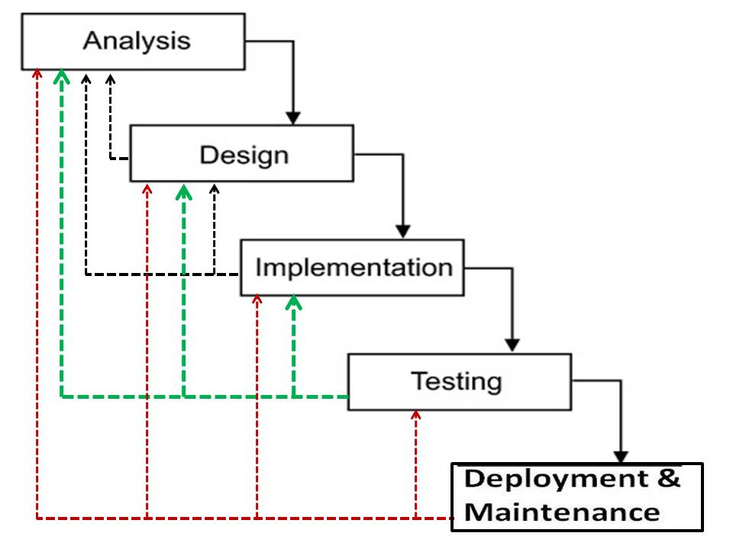

* 1. **Justification for the Selection of Model :**
* In Waterfall Model less time is spent on documenting and more time is given for designing.
* Building and improving the product step by step. Hence we can track the defects at early stages. This avoids the downward flow of the defects.
* We can go to any previous phase as per the requirements.
* Testing and debugging during smaller iteration is easy.
* Waterfall model works well for smaller projects where requirements are not very well understood.

1. **Future scope of the project:**

We can consider much future scope to this application. The following are some of them:

* QR code Generation for more reliability.

1. **Sources:**

Web links ->

[www.w3school.com](http://www.w3school.com)

[www.javatpoint.com](http://www.javatpoint.com)

[www.geeksforgeeks.org](http://www.geeksforgeeks.org)

Textbooks ->

Stephen Walther, Pearson Education, second Edition, 2004

Ivan Bay Ross,(“HTML, JavaScript”)